# Project Title:

**Effective Knowledge Management: From Article Creation to Approval**

# Project Description:

To efficiently create and gain approval for a comprehensive Knowledge Article within the ServiceNow platform, ensuring that the information is accurate, accessible, and beneficial for users seeking solutions or guidance. The project aims to streamline the knowledge management process, enhance user experience, and reduce support ticket volumes by providing readily available, high-quality documentation.

## Team Members:

## ARUTSELVAN. S – [arutselvan1807@gmail.com](mailto:arutselvan1807@gmail.com)

## MOHAMMED AFRIDI. A- [affifmohammed90@gmail.com](mailto:affifmohammed90@gmail.com)

## SANKARA NARAYANA HARI. R- [r.s.n.hari045@gmail.com](mailto:r.s.n.hari045@gmail.com)

## JEEVANANTHAM. A - [mcjeeva1623@gmail.com](mailto:mcjeeva1623@gmail.com)

## Implementation:

**Activity-1 : Create Users**

1. Open service now.
2. Click on All  >> search for users
3. Select Users under system security
4. Click on new
5. Fill the following details to create a new user

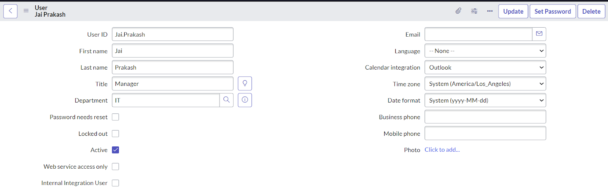

1. Click on Submit.

**Activity - 2: Create Groups**

1. Open service now.
2. Click on All  >> search for groups
3. Select groups under system security
4. Click on new
5. Fill the following details to create a new group.

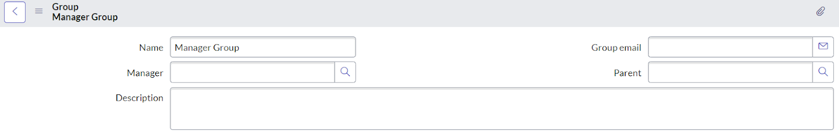

1. Under Group Members, click on edit.
2. Add the user(Jai Prakash) to the Manager Group and click on Save.

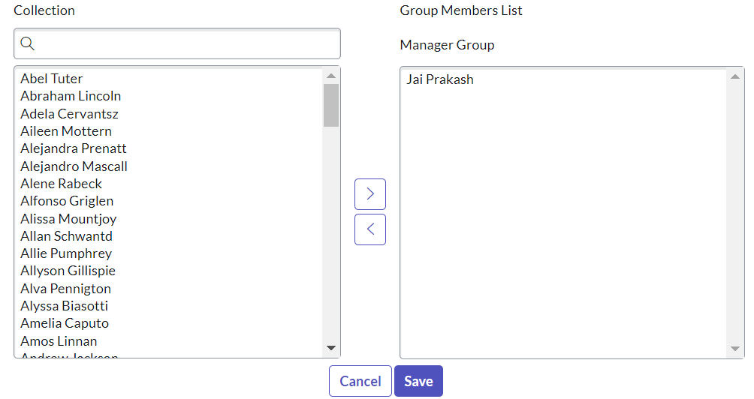

1. It would like below.

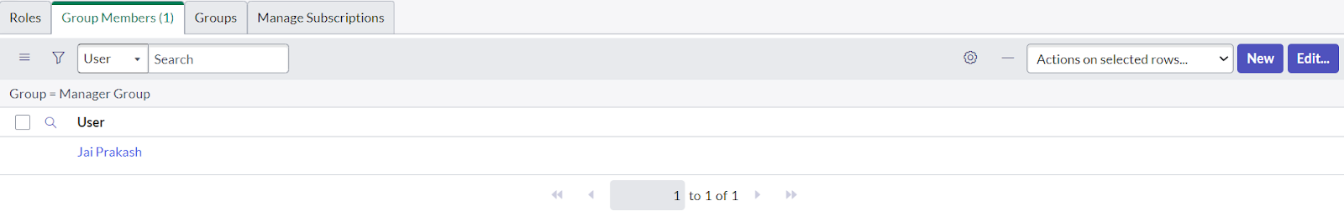

1. Click on save.

**Activity - 3: Create Roles**

1. Open service now.
2. Click on All  >> search for roles
3. Select roles under system security
4. Click on new
5. Fill the following details to create a new role

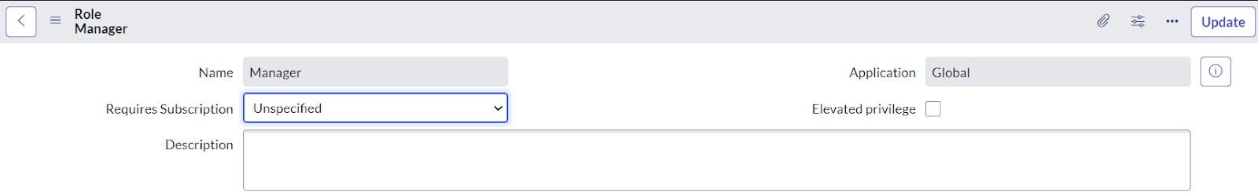

1. Click on submit.

**Activity - 4: Changing the Owner of the Knowledge Base**

1. Go to All >> Search for Knowledge Bases.

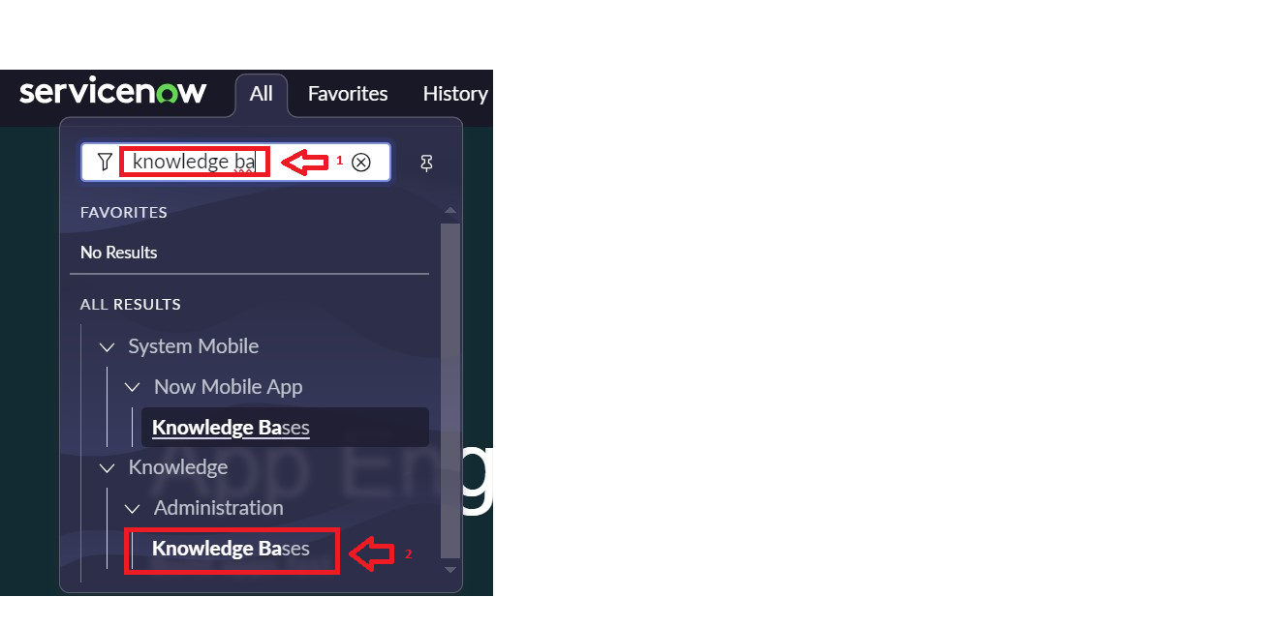

1. Open Knowledge bases and change the of IT from Bernard Laboy to Jai Prakash(To change Owner click on the Name and change it)

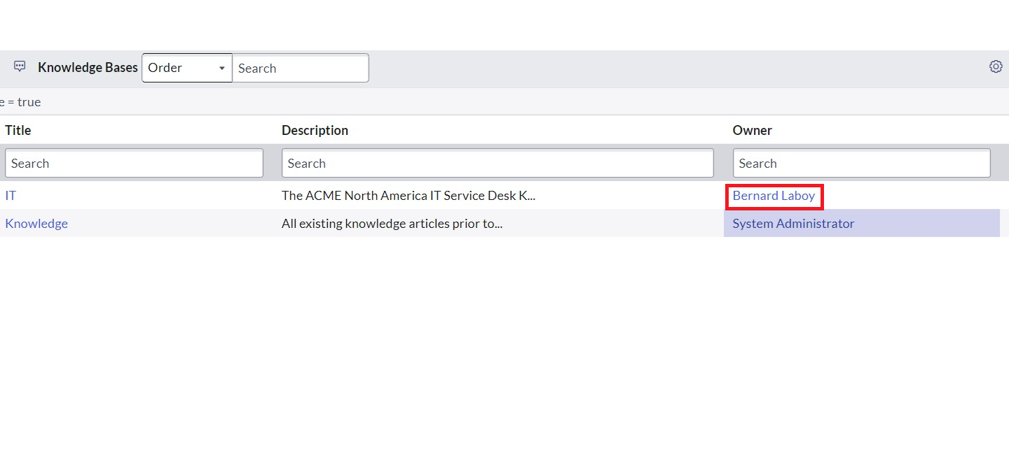

1. It would look like below.

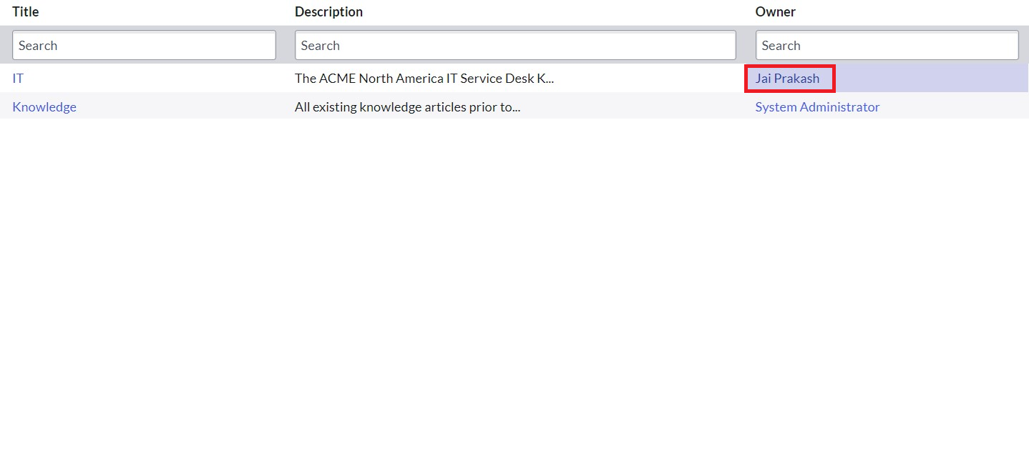

**Activity - 5: Creation of Knowledge Article.**

1. Go to All >> Search for my knowledge Articles.

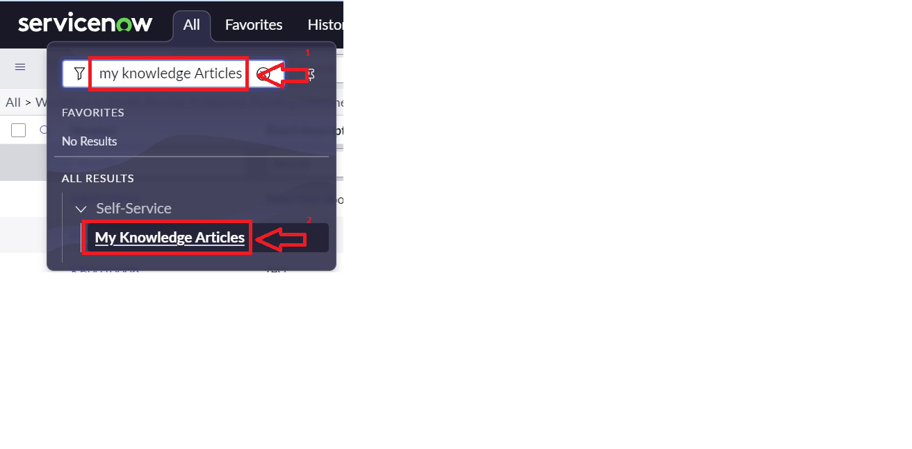

1. Open my knowledge Articles >> Click New.
2. Fill the details as below:

Number :Auto-generated.

Knowledge base :IT

Category :Select any category

Short description :Describes about Cloud Computing. (Give Short description as per  your requirement)

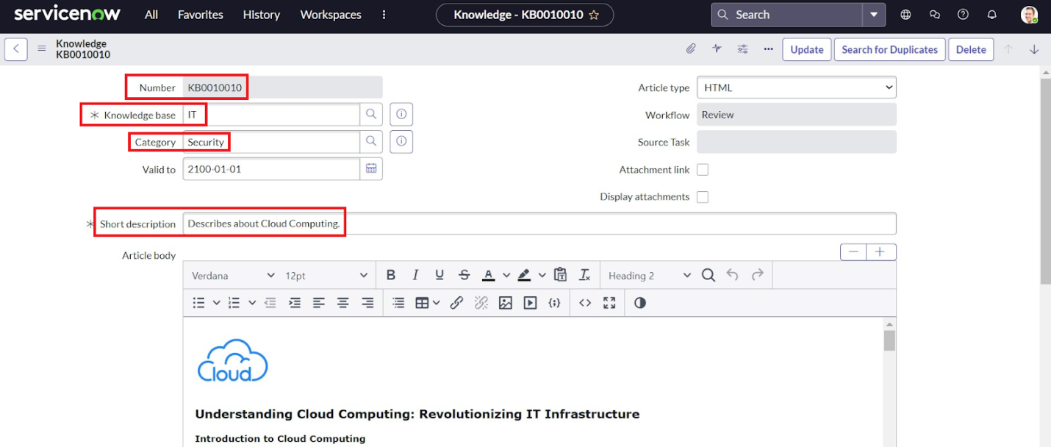

Article body :(paste your knowledge Article here)

##Below is the Knowledge article used in this project, you can create article based on your requirement



**Understanding Cloud Computing: Revolutionizing IT Infrastructure**

**Introduction to Cloud Computing**

Cloud computing is a transformative technology that has revolutionized the way businesses and individuals manage, store, and process data. It refers to the delivery of computing services—including servers, storage, databases, networking, software, analytics, and intelligence—over the internet ("the cloud") to offer faster innovation, flexible resources, and economies of scale.

**Key Concepts in Cloud Computing**

**1. Service Models**

Cloud computing services are typically categorized into three fundamental models:

* Infrastructure as a Service (IaaS):IaaS provides virtualized computing resources over the internet. It allows businesses to rent servers, storage, and networking resources on a pay-as-you-go basis. Examples include Amazon Web Services (AWS), Microsoft Azure, and Google Cloud Platform (GCP).
* Platform as a Service (PaaS):PaaS offers hardware and software tools over the internet, typically used for application development. A PaaS provider hosts the hardware and software on its own infrastructure. Examples include Microsoft Azure PaaS, Google App Engine, and Heroku.
* Software as a Service (SaaS):SaaS delivers software applications over the internet, on a subscription basis. Users can access SaaS applications through web browsers, reducing the need for internal infrastructure. Examples include Salesforce, Microsoft Office 365, and Google Workspace.

**2. Deployment Models**

Cloud services can be deployed in various ways depending on the needs of the organization:

* Public Cloud:Services are delivered over the public internet and shared across multiple organizations. It is cost-effective and scalable but may have less security and privacy.
* Private Cloud:Services are maintained on a private network, dedicated to a single organization. It offers enhanced security and control but can be more expensive.
* Hybrid Cloud:Combines public and private clouds, allowing data and applications to be shared between them. It provides greater flexibility and optimization of existing infrastructure, security, and compliance.

**3. Key Characteristics**

* On-Demand Self-Service:Users can provision computing resources as needed without requiring human interaction with each service provider.
* Broad Network Access:Services are available over the network and accessed through standard mechanisms that promote use by heterogeneous thin or thick client platforms.
* Resource Pooling:The provider’s computing resources are pooled to serve multiple consumers using a multi-tenant model, with different physical and virtual resources dynamically assigned and reassigned according to demand.
* Rapid Elasticity:Capabilities can be elastically provisioned and released to scale rapidly outward and inward commensurate with demand.
* Measured Service:Cloud systems automatically control and optimize resource use by leveraging a metering capability at some level of abstraction appropriate to the type of service (e.g., storage, processing, bandwidth).

**Benefits of Cloud Computing**

* Cost Efficiency:Reduces the capital expense of buying hardware and software and setting up and running on-site data centers.
* Scalability:Allows businesses to scale up or down based on demand, providing flexibility and avoiding over-provisioning or under-provisioning.
* Performance:Large cloud services run on a worldwide network of secure data centers, which are upgraded to the latest generation of fast and efficient computing hardware.
* Security:Many cloud providers offer a set of policies, technologies, and controls that strengthen your security posture overall, helping protect data, apps, and infrastructure from potential threats.
* Collaboration Efficiency:Cloud applications improve collaboration by allowing dispersed groups of people to meet virtually and easily share information in real-time and via shared storage.

**Challenges of Cloud Computing**

* Security and Privacy:Ensuring the security of data and compliance with regulations are the top concerns, especially when dealing with sensitive data.
* Downtime:Dependence on internet connectivity means that any disruption in the internet service can affect access to cloud services.
* Limited Control:Using cloud infrastructure means relying on service providers for hardware and network maintenance, reducing the level of control an organization has over its IT environment.
* Compliance:Keeping data compliant with local and international regulations can be challenging, especially when data is stored in multiple locations around the world.

1. Click on Submit.
2. Click on Publish.

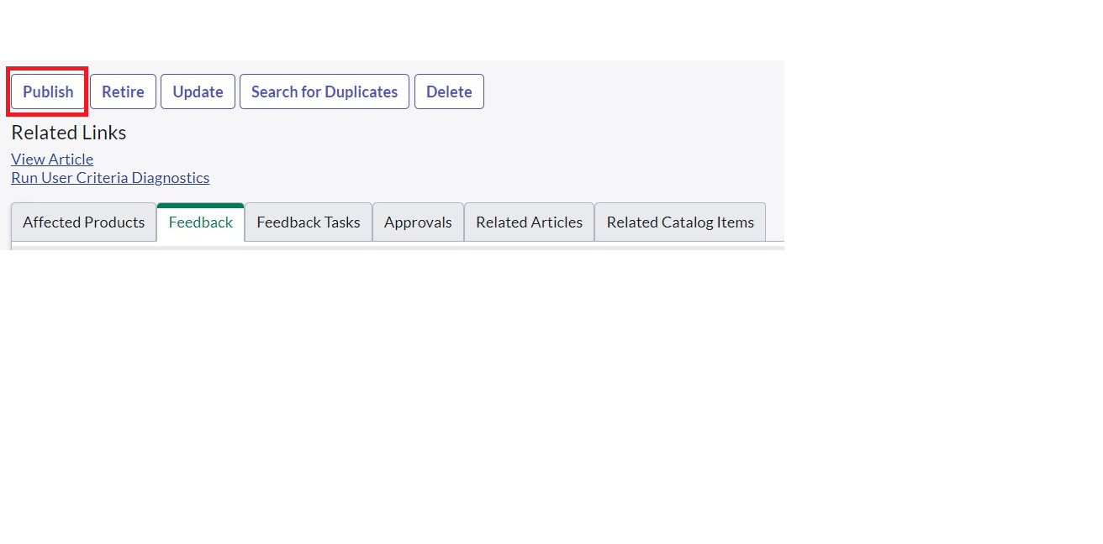

1. Open that Knowledge Article again.
2. We can see that the Knowledge Article has been assigned to the user you created under approvals.

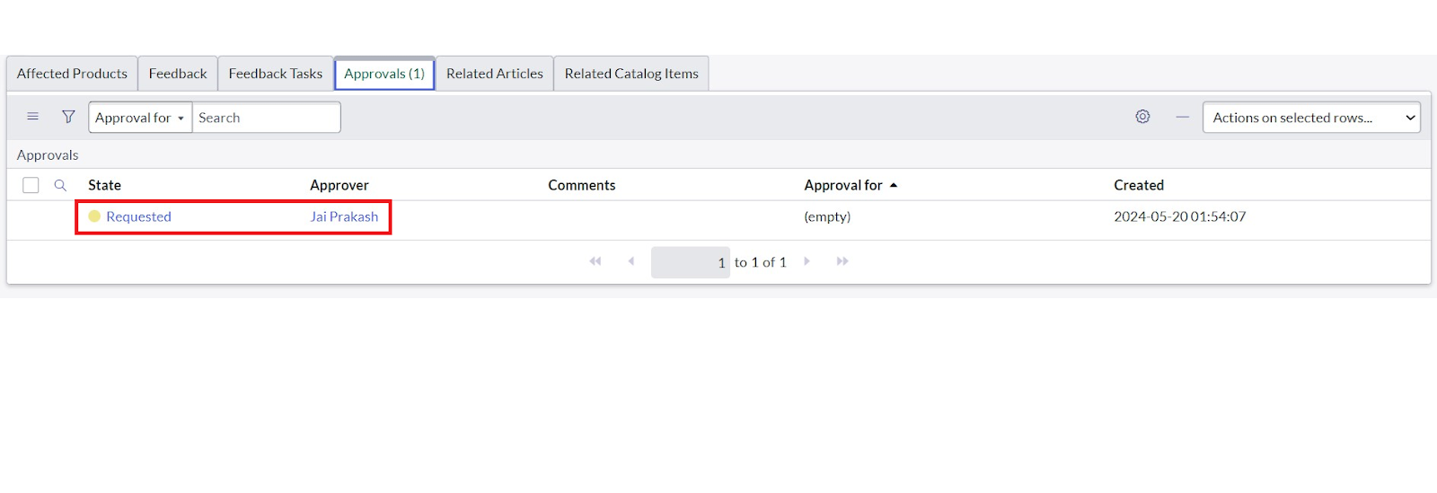

## RESULT:

1. To verify weather the email is send for approval or not.
2. Go to All, search for emails.
3. Under System logs click on Emails.

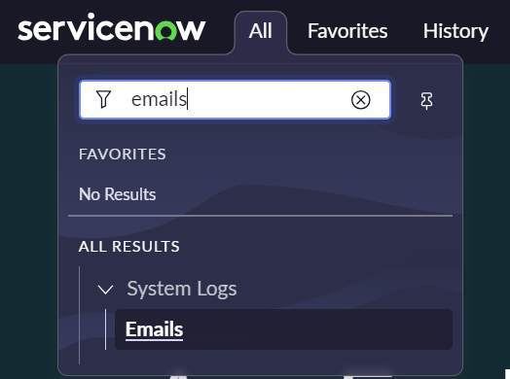

1. There you can see that the email has been sent.

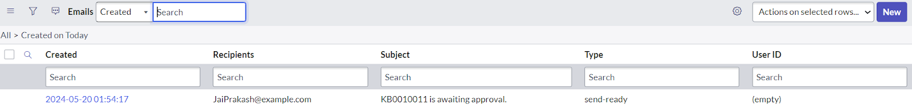

## My Output:

**Screenshots:**

**1.**

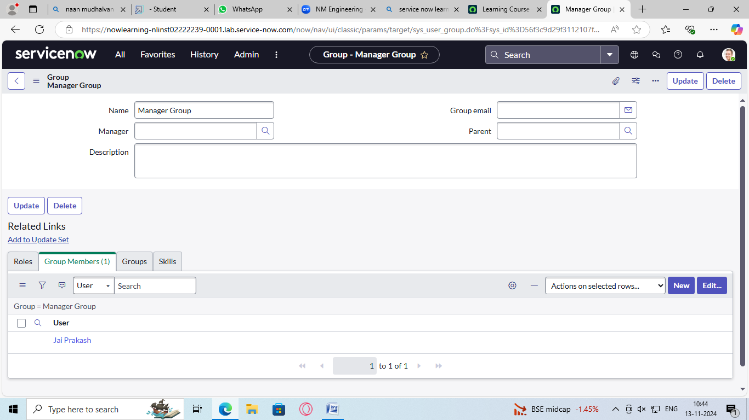

**2.**

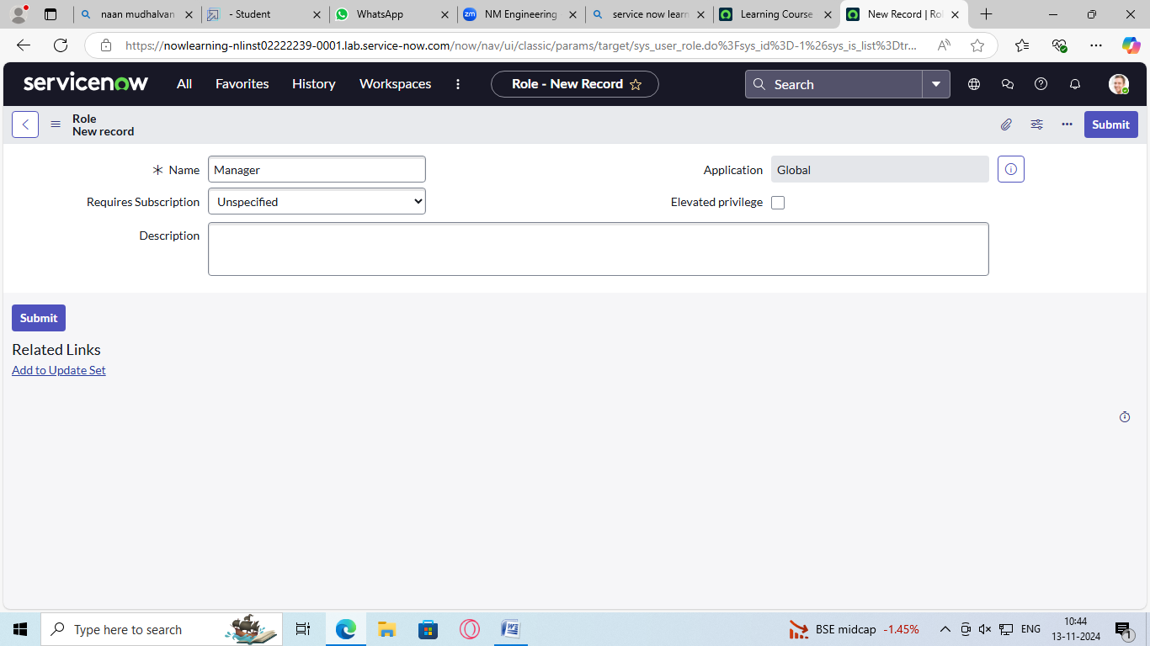

**3.**

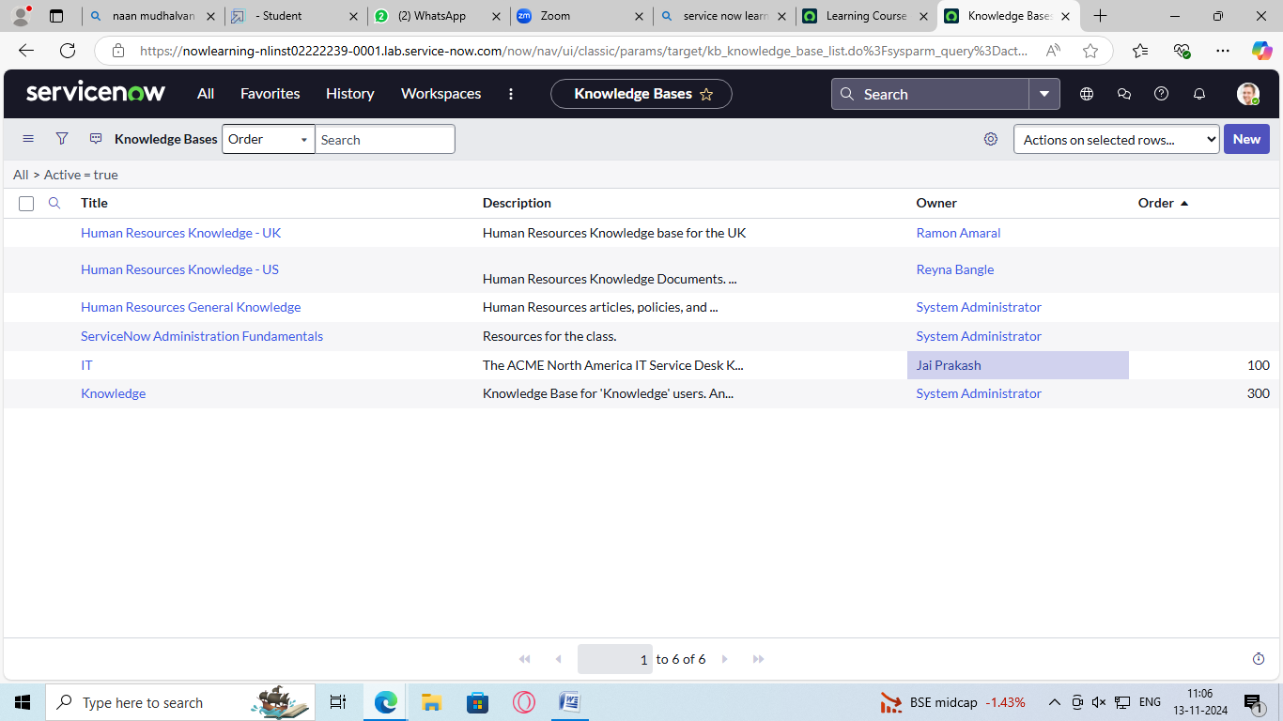

**4.**

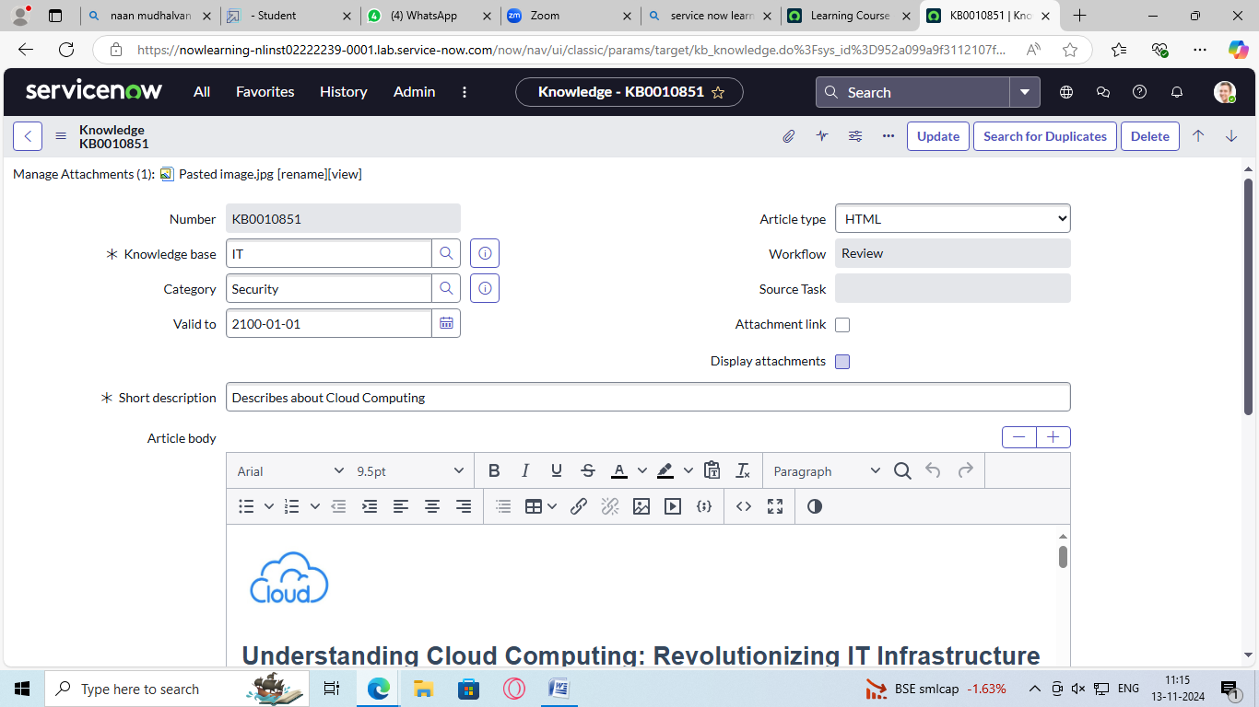

**5.**

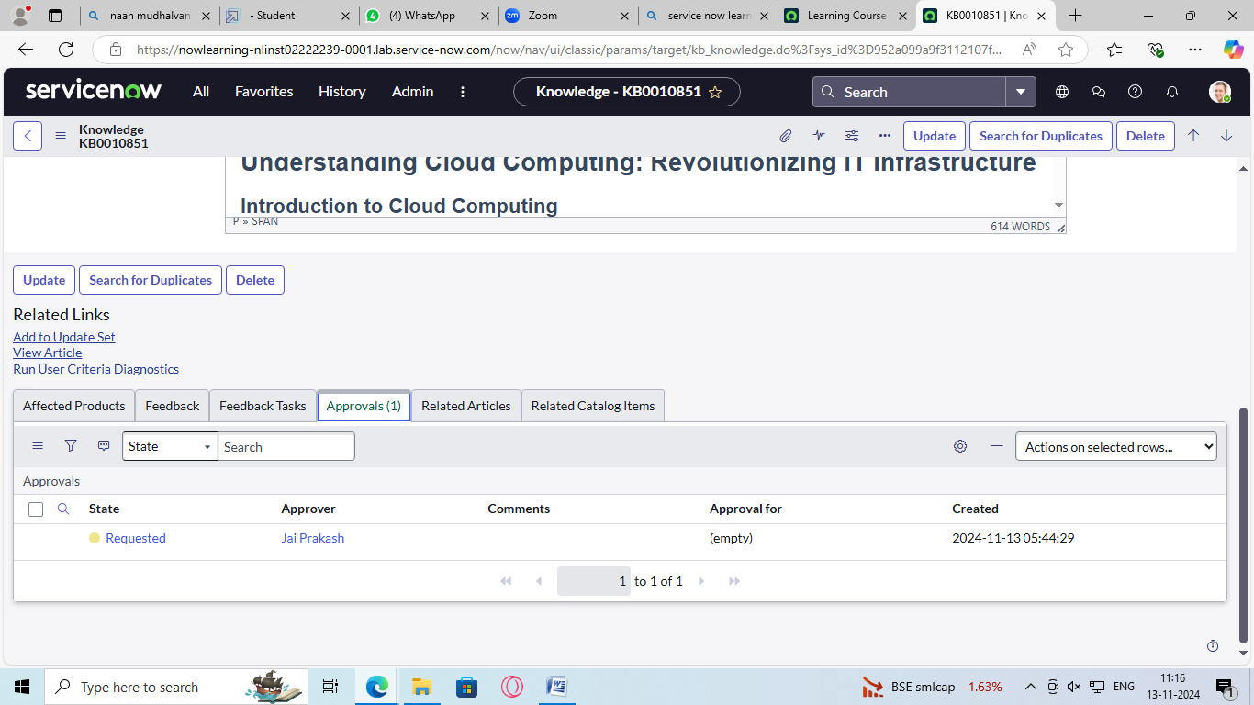

**6.**

